1)

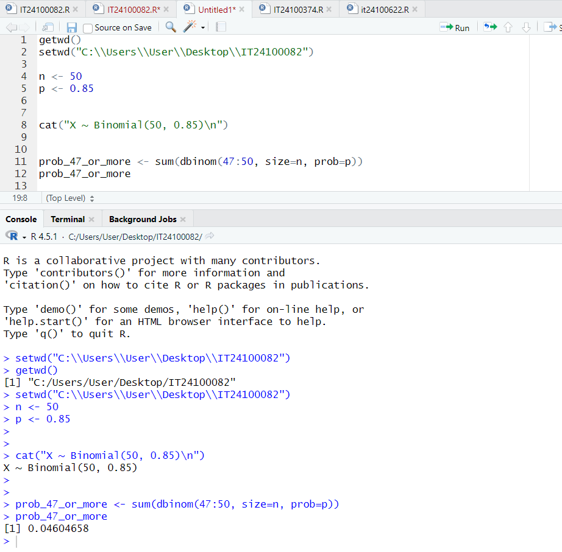

2)